Student Id – IT24100551

Name – KARUNATHILAKA K.D.J.C

Lab sheet 10

1

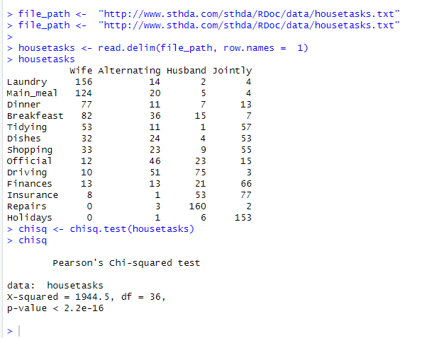

3

